Bec Sharp
04/05/2026
Stakeholders
For this project, my two groups of stakeholders are tech inclined students who are actively working to decide their desired level of education, and a tech company, to understand whether or not they have competitive compensation standards in today's environment. Ideally, this would be displayed for the students close to a graduation or at other stages of their schooling, to help them determine if they want to continue pursuing education for higher degrees. This is a decision that is a long-term investment for the student. For the company, it should be a recurring evaluation for if they are offering an appropriate salary to keep up with the pay of similar technical roles in the United States. This would help the company with employee retention and maintaining their competitiveness in their field. Given the scenario, the students are included as interns or employees, since the data included in my visualizations could be beneficial for deciding whether to return to school or continue while working with the company. As a student currently pursuing my Master’s degree, I would be considered a part of that first group of stakeholders.

Data Story
As we continue to pursue a better future for ourselves, we eventually must decide whether or not to attend further education. The provided visualizations are intended to assist this decision by displaying the average income improvement for technical roles at each level of education. The difference between pay between degree levels is substantial and worthwhile for consideration for all people in the tech field. The second set of visualizations can assist companies in deciding on appropriate salaries for their employees. With so many people entering the tech field, it is important to ensure that there is a high enough salary offered to get and maintain good employees. We can see that a majority of salaries are within a rough $50,000 range but there are several that pay significantly less than average. A good company should pay within or above the average tech pay in order to attract high quality employees, by viewing the visualizations, the company can make this comparison and decide on wage changes. While a higher education is associated with increased earning potential, the variability within technical roles suggests that education does not alone guarantee consistently higher pay.

Visualization Effectiveness
Bar charts are especially effective in communicating the increase in pay associated with higher degrees earned, with a clear visual of the change in these categories. Including the average line helps put the numbers into perspective for the audience which helps their decision making. The second bar chart mimics this same benefit while also displaying the difference between technical role averages and actual salary average; this would be best for people who haven’t yet determined whether or not to enter the technical sector. It clearly displays the difference with limited cognitive load. The box and whisker plot shows the typical salary ranges with an intended focus point on the box portion, representing the majority of salaries. The salary growth scatterplot effectively displays a similar range, but over years of experience. This is an intentional addition to ensure the salary adjustments would be appropriately made across all levels of employee, rather than an unintentional focus on early career only. While these are more technical than the student view bar charts, they display more meaningful information that is able to be utilized by a company.

Audience Tailored for Students
The following bar charts were tailored to the student audience, intended to be simple and possible to understand at a glance. They are colorblind accessible with distinguishing colors for easy reading that prevent misinterpretation of the data. The simplicity and accessibility help the audience understand and connect with the visualizations. The addition of the average trend line on this first chart helps guide the audience to the takeaway that a higher education greatly increases typical earnings.
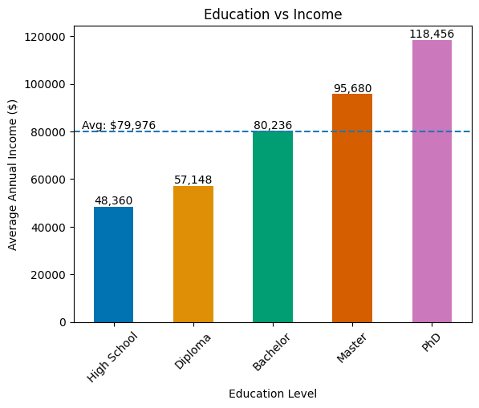

The secondary bar chart compares early technical career salaries with the national average income by their education level. This showcases that while education increases earnings, the magnitude varies greatly within technical roles. This chart focuses on early careers as they are likely to be thinking of whether or not to expand their education, and the wage gap with the top earners in tech is substantial. These two charts are intended to be used in tandem for making a decision for that group of stakeholders, with a specific focus on simplicity and readability.

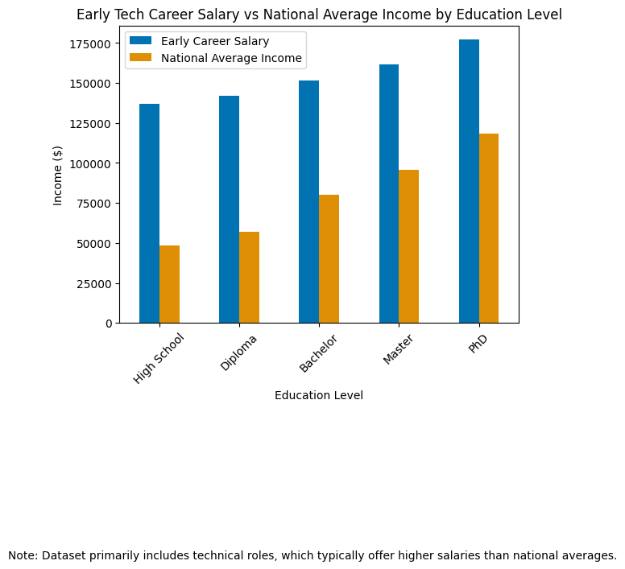
Audience Tailored for Tech Companies
The visualizations made for tech companies are of a higher complexity, intended to display the growth over time and compare salaries earned by the employees rather than the wage difference between education levels. The box and whisker plot is kept as simple as possible with lines in the background to help the audience identify key points which otherwise may be lost. Using this graph, the company is able to compare its own salaries and see where they fall within it. This is best done with information already in mind as to what the company will typically pay for their employees.
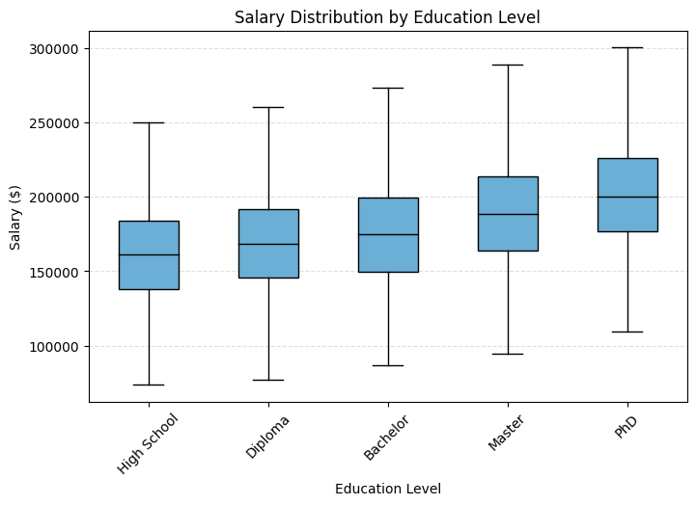

The scatterplot includes an interquartile range to assist this visualization instead of years of experience. This is a measurement able to be used and easily visualize whether or not a
company's wage practices fall within the typical range while reducing influence of extreme outliers. This graph, like the rest, is focused on colorblind accessibility and readability with contrasting colors used for ease of reading.

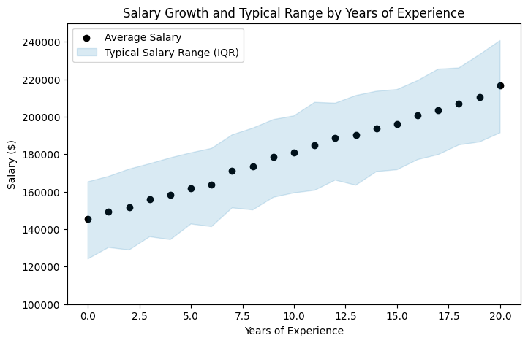

Conclusions
Possible conclusions intended to be drawn from these visualizations for the two groups of stakeholders share similar findings. There is a distinct correlation between higher education levels and higher earnings on average. This should be used to guide a company to drive their salaries to be competitive in today's market, and avoid failing to keep up with their employees' growth. The students should look at this data and decide whether or not it is worth it for them to continue their education, with simple visualizations that display the increase at each level.

